11.1.8 Editors - Compositor Editor - Header - Add Menu - Color
Detailed Table of Content 1
Add menu - Color 5
Alpha Over 5
Bright/Contrast 6
Color Balance 7
Color Correction 8
Gamma 9
Hue Correct 10
Hue Saturation 11
Invert Node 12
Mix 13
RGB Curves 14
Tone Map 16
Z Combine 17

Detailed Table of Content

Detailed table of content
Detailed Table of Content 1
Add menu - Color 5
Alpha Over 5
Inputs 5
Factor 5
Image 5
Image 5
Properties 5
Convert Premultiplied 5
Premultiply 5
Outputs 6
Image 6
Bright/Contrast 6
Inputs 6
Color 6
Brightness 6
Contrast 6
Properties 6
Convert Premultiplied 6
Outputs 6
Color 6
Color Balance 7
Inputs 7
Factor 7
Image 7
Properties 7
Correction Formula 7
Lift/Gamma/Gain 7
Lift 7
Gamma 7
Gain 7
Offset/Power/Slope (ASC-CDL) 7
Offset 7
Basis 7
Power 7
Slope 7
Outputs 7
Color 7
Advanced 8
The Offset/Power/Slope Formula 8
Color Correction 8
Input 8
Image 8
Mask 8
Properties 8
Red, Green, Blue 8
Correction Tools (Columns) 8
Saturation 8
Contrast 8
Gamma 8
Gain 9
Lift 9
Tonal Ranges (Rows) 9
Master 9
Highlights 9
Mid tones 9
Shadows 9
Mid tones Start, Mid tones End 9
Outputs 9
Color 9
Gamma 9
Inputs 9
Image 9
Gamma 9
Outputs 10
Image 10
Hue Correct 10
Inputs 10
Factor 10
Image 10
Properties 10
Navigation elements 10
Zoom in and out 10
Tools 10
Reset View 10
Vector Handle 10
Auto Handle 10
Auto Clamped Handle 10
Extend horizontal 11
Extend extrapolated 11
Reset Curve 11
Use Clipping 11
Delete Points 11
Curve 11
X / Y 11
Outputs 11
Image 11
Hue Saturation 11
Inputs / Properties 11
Image 11
Hue 11
Saturation 12
Value 12
Factor 12
Color 12
Outputs 12
Image 12
Hue/Saturation Tips 12
Invert Node 12
Inputs 13
Factor 13
Color 13
Properties 13
RGB 13
Alpha 13
Outputs 13
Color 13
Mix 13
Inputs 13
Factor 13
Image 1 13
Image 2 13
Properties 13
Mix 13
Clamp 14
Outputs 14
Image 14
RGB Curves 14
Inputs 14
Factor 14
Image 14
Black Level 14
White level 14
Properties 14
Tone 14
Channel buttons 14
Curve edit field 14
Selecting Points 14
Adding Points 15
Navigation elements 15
Zoom in and out 15
Tools 15
Reset View 15
Vector Handle 15
Auto Handle 15
Auto Clamped Handle 15
Extend horizontal 15
Extend extrapolated 15
Reset Curve 15
Use Clipping 15
Delete Points 16
Outputs 16
Color 16
Tone Map 16
Inputs 16
Image 16
Properties 16
Type 16
Rh Simple 16
Key 16
Offset 16
Gamma 16
R/D Photo receptor 16
Intensity 16
Contrast 16
Adaptation 17
Color Correction 17
Outputs 17
Image 17
Z Combine 17
Inputs 17
Image 17
Z 17
Image 17
Z 17
Properties 17
Use Alpha 17
Anti-Alias Z 17
Outputs 18
Image 18
Z 18

Add menu - Color

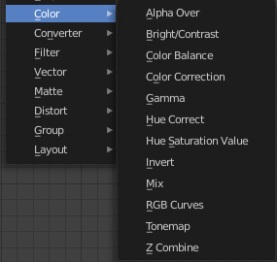
Here you find color related nodes.

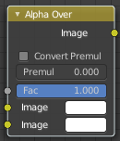
Alpha Over
The Alpha Over node is used to layer images with an alpha channel on top of one another.
Where the foreground image pixels have an alpha greater than 0, the background image will be overlaid.

Inputs

Factor
Controls the amount of foreground image. A factor less than 1 will make the foreground more transparent.

Image
Input for the background image.

Image
Input for the foreground image.

Properties

Convert Premultiplied
Converts foreground image to premultiplied alpha format.
The Alpha Over node is designed to work with premultiplied alpha color format. Use Convert Premul when you know that your image has straight alpha color values, to perform the correct over operation. Result will be still premultiplied alpha.

Premultiply
The Premul slider allows to mix between the using premultiplied or non premultiplied alpha.
When set to 1, the foreground color values will be multiplied by alpha, i.e. premultiplied. This is equivalent to enabling the Convert Premul option. When set to 0, color values does not change.

If Premultiply is not zero, Convert Premul will be ignored.
Note that this is a legacy option.

Outputs

Image
The image output.

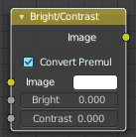
Bright/Contrast

Inputs

Color
Standard input.

Brightness
An additive-type factor by which to increase the overall brightness of the image. Use a negative number to darken an image.

Contrast
A scaling type factor by which to make brighter pixels brighter, but keeping the darker pixels dark. Higher values make details stand out. Use a negative number to decrease the overall contrast in the image.

Properties

Convert Premultiplied
Converts foreground image to premultiplied alpha format.
The Alpha Over node is designed to work with premultiplied alpha color format. Use Convert Premul when you know that your image has straight alpha color values, to perform the correct over operation. Result will be still premultiplied alpha.

Outputs

Color
Standard output.
Note. It is possible that this node will put out a value set that has values beyond the normal range, i.e. values greater than one and less than zero. If you will be using the output to mix with other images in the normal range, you should clamp the values using the Map Value node (with the Min and Max enabled), or put through a Color Ramp node (with all normal defaults).

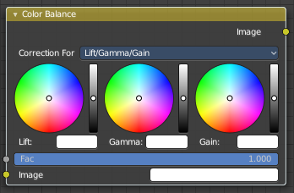
Color Balance
The Color Balance node can adjust the color and values of an image.

Inputs

Factor
Controls the amount of influence the node exerts on the output image.

Image
Standard image input.

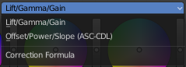
Properties

Correction Formula
Two different correction formulas could be selected.

Lift/Gamma/Gain

Lift
Increases the value of dark colors.

Gamma
Will adjust mid tones.

Gain
Adjusts highlights.

Offset/Power/Slope (ASC-CDL)

Offset
Summand. (Adjusts the overall brightness.)

Basis
Additional offset, allows to specify a negative Offset value.

Power
Over-all exponent. (Adjusts the mid tones.

Slope
Multiplier. (Adjusts the highlights.)

Outputs

Color
The output image.

Advanced

The Offset/Power/Slope Formula
out = (i × s + o)p
where:
out: The color graded pixel code value.
i: The input pixel code value (0 to 1) (black to white).
s: Slope (any number 0 or greater, nominal value is 1.0).
o: Offset (any number, the nominal value is 0).
p: Power (any number greater than 0, nominal value is 1.0).

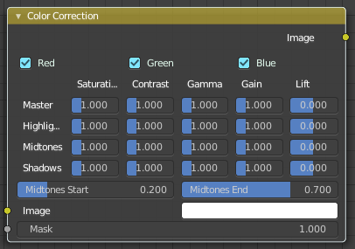
Color Correction
With the Color Correction node you can adjust the color of an image. Separated in several tonal ranges (highlights, mid tones and shadows) and only affect the necessary RGB channels.

Input

Image
Image Input.

Mask
Input a mask to cover parts of the image so that they are affected.

Properties

Red, Green, Blue
Specifies which RGB channels will be affected by correction.

Correction Tools (Columns)

Saturation
Adjusts the image’s saturation.

Contrast
Adjust image contrast.

Gamma
Exponential gamma correction, affecting the mid tones of the image. (Works like Power in the Color Balance node.)

Gain
Multiplier, stronger influence on the highlights. (Works like Slope in the Color Balance node.)

Lift
This value (can be negative) will be added (+), linear lightens or darkens the image. (Works like Offset in the Color Balance node.)

Tonal Ranges (Rows)

Master
These sliders affect the entire tonal range.

Highlights
These sliders only affect the highlights.

Mid tones
These sliders only affect the mid tones.

Shadows
Affects the dark tones of an image often affecting the shadows.

Mid tones Start, Mid tones End
Defines the start and the end of mid tones range, i.e. values where the whole tonal range is divided into the highlights, mid tones and shadows (there is also a smooth transition between the ranges of width 0.2 units).

Outputs

Color
The image output.

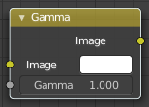
Gamma
Use this node to apply a gamma correction.

Inputs

Image
Image input.

Gamma
An exponential brightness factor.

Outputs

Image
Image output.

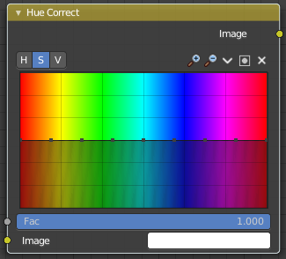
Hue Correct
With the Hue Correct Node you can adjust the Hue, Saturation, and Value of an image with an input curve.

Inputs

Factor
Controls the amount of influence the node exerts on the output image.

Image
Standard image input.

Properties
Level
H (Hue), S (Saturation), V (Value). Choose which curve you want to modify.

Navigation elements
The navigation elements at the top are described from left to right.

Zoom in and out
The two buttons with the magnifying glass at it zooms in and out in the curve window.

Tools

Tools is a menu where you can find some curve related tools.

Reset View
Resets the curve windows zoom.

Vector Handle
Set handle type to Vector.

Auto Handle
Set handle type to Auto.

Auto Clamped Handle
Set handle type to Auto Clamped.

Extend horizontal
Extends the curve before the first curve point and behind the last curve point horizontally.

Extend extrapolated
Extends the curve before the first curve point and behind the last curve point extrapolated.

Reset Curve
Resets the curve to the initial shape.


Use Clipping
Clipping options. Set up clipping for the stroke.

Delete Points
Deletes selected curve points.

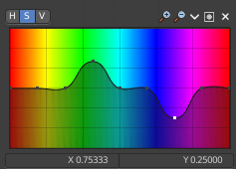
Curve
By default, the curve is a straight line, meaning there is no change. The spectrum allows you to raise or lower HSV levels for each range of pixel colors. To change an H, S, or V level, move the curve points up or down. Pixels with hue values each point in the horizontal position of the graph will be changed depending on the shape of the curve.

X / Y
The x y position of the currently selected curve point.

Outputs

Image
Image output.

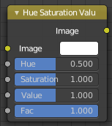
Hue Saturation
The Hue Saturation Node applies a color transformation in the HSV color space. Called “Hue Saturation Value” in shader and texture context.

Inputs / Properties
The inputs also works as properties when nothing is connected.

Image
Plug in an image.

Hue
Specifies the hue rotation of the image. 360° are mapped to (0 to 1). The hue shifts of 0 (-180°) and 1 (+180°) have the same result.

Saturation
A saturation of 0 removes hues from the image, resulting in a gray scale image. A shift greater than 1.0 increases saturation.

Value
Value is the overall brightness of the image. De/Increasing values shift an image darker/lighter.

Factor
Controls the amount of influence the node exerts on the output image.

Color
Standard input.

Outputs

Image
Standard output.

Hue/Saturation Tips
Some things to keep in mind that might help you use this node better:
Hues are vice versa
A blue image, with a Hue setting at either end of the spectrum (0 or 1), is output as yellow (recall that white, minus blue, equals yellow). A yellow image, with a Hue setting at 0 or 1, is blue.
Hue and Saturation work together.
So, a Hue of 0.5 keeps the blues the same shade of blue, but Saturation can deepen or lighten the intensity of that color.
Gray & White are neutral hues
A gray image, where the RGB values are equal, has no hue. Therefore, this node can only affect it with Value. This applies to all shades of gray, from black to white; wherever the values are equal.
Changing the effect over time
The Hue and Saturation values can be animated with a Time Node or by animating the property.

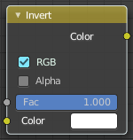
Invert Node
The Invert Node inverts the colors in the input image, producing a negative.

Inputs

Factor
Controls the amount of influence the node exerts on the output image.

Color
Standard input.

Properties

RGB
Invert the RGB values.

Alpha
Invert the Alpha values.

Outputs

Color
Standard image output.

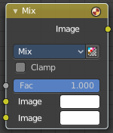
Mix
The Mix Node mixes images by working on the individual and corresponding pixels of the two input images. Called “MixRGB” in the shader and texture context.

Inputs

Factor
Controls the amount of influence the node exerts on the output image.

Image 1
Usually the background image. The image size and resolution sets the dimensions of the output image.

Image 2
Usually he foreground image.

Properties

Mix
Choose the different blending modes.
Add, Subtract, Multiply, Screen, Divide, Difference, Darken, Lighten, Overlay, Color Dodge, Color Burn, Hue, Saturation, Value, Color, Soft Light, Linear Light.

Clamp
Limit the highest color value to not exceed 1.

Outputs

Image
Image output.

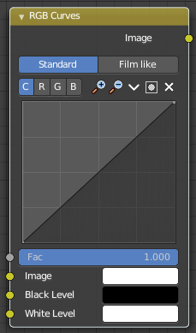
RGB Curves
The RGB Curves Node allows color corrections for each color channel and levels adjustments in the compositing context.

Inputs

Factor
Controls the amount of influence the node exerts on the output image.

Image
Standard image input.

Black Level
Defines the input color that is (linear) mapped to black.

White level
Defines the input color that is (linear) mapped to white.

Properties

Tone
What tone mapping to use. Standard or Film like.

Channel buttons
Clicking on one of the channels displays the curve for each.
C (Combined RGB), R (Red), G (Green), B (Blue).

Curve edit field
Create and tweak a Bezier curve that varies the input levels (X axis) to produce an output level (Y axis).


Selecting Points
You can select curve points. This reveals two edit boxes for the x and y coordinate of this point.
Selected points can be moved around. Left click at them, hold the mouse button down and move them to a new location.


Adding Points
You can add new curve points by simply left clicking at the curve. Move the mouse to position them where you need it.

Navigation elements
The navigation elements at the top are described from left to right.

Zoom in and out
The two buttons with the magnifying glass at it zooms in and out in the curve window.

Tools
Tools is a menu where you can find some curve related tools.

Reset View
Resets the curve windows zoom.

Vector Handle
Set handle type to Vector.

Auto Handle
Set handle type to Auto.

Auto Clamped Handle
Set handle type to Auto Clamped.

Extend horizontal
Extends the curve before the first curve point and behind the last curve point horizontally.

Extend extrapolated
Extends the curve before the first curve point and behind the last curve point extrapolated.

Reset Curve
Resets the curve to the initial shape.

Use Clipping
Clipping options. Set up clipping for the stroke.

Delete Points
Deletes selected curve points.

Outputs

Color
Standard output.

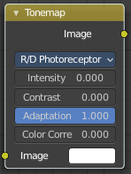
Tone Map
Tone mapping is a technique used in image processing and computer graphics to map one set of colors to another in order to approximate the appearance of high dynamic range images in a medium that has a more limited dynamic range.
Tone mapping addresses the problem of strong contrast reduction from the scene values (radiance) to the displayable range, while preserving the image details and color appearance. This is important to appreciate the original scene content.

Inputs

Image
Plug in the HDR image.

Properties

Type
There are two methods of tone mapping. Rh Simple and R/D Photo receptor.

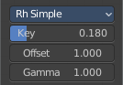
Rh Simple

Key
The value the average luminance is mapped to.

Offset
Normally always 1, but can be used as an extra control to alter the brightness curve.

Gamma
If not used, set to 1.

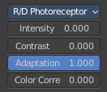
R/D Photo receptor

Intensity
A value smaller than zero darkens image. A value greater than zero makes it brighter.

Contrast
Set to 0 to use estimate from input image.

Adaptation
If 0, global; if 1, based on pixel intensity.

Color Correction
If 0, same for all channels; if 1, each independent.

Outputs

Image
The Image output.

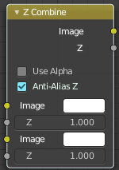
Z Combine
The Z Combine node combines two images based on their Z-depth maps. It overlays the images using the provided Z values to detect which parts of one image are in front of the other.

Inputs

Image
The background image.

Z
Z depth of the background image.

Image
The foreground image.

Z
Z depth of the foreground image.

Properties

Use Alpha
The chosen Image pixel alpha channel is also carried over. If a pixel is partially or totally transparent, the result of the Z Combine will also be partially transparent; in which case the background image will show through the foreground (chosen) pixel.

Anti-Alias Z
Applies Anti-Aliasing to avoid artifacts at sharp edges or areas with a high contrast.

Outputs

Image
If both Z values are equal, it will use the foreground image. Whichever Z value is less decides which image pixel is used. See Z-buffer.

Z
The combined Z depth, which allows to thread multiple Z-combines together.

